Usando questi strumenti unisci i puntini . . .otterrai ?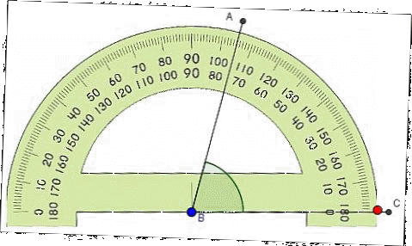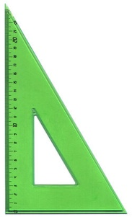

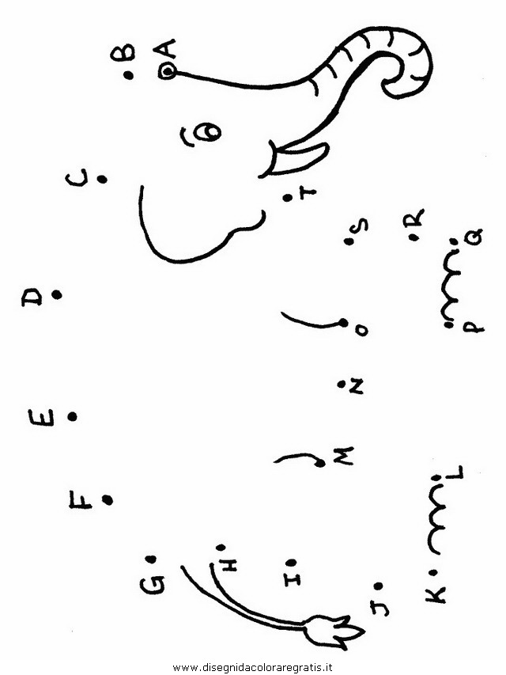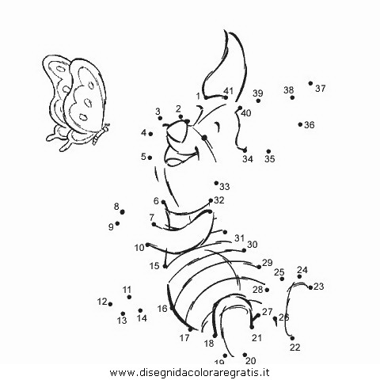

[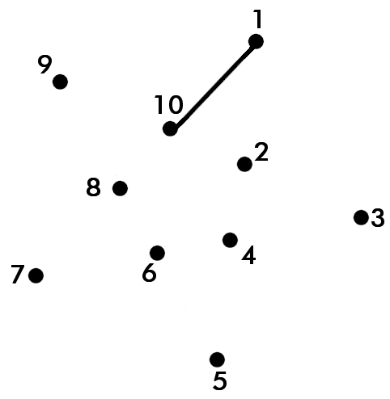](http://www.google.it/url?sa=i&source=images&cd=&cad=rja&docid=3TKrunqzqVykZM&tbnid=KJGvfhNQV5XCKM:&ved=0CAgQjRwwAA&url=http%3A%2F%2Fwww.myfrancescasanti.com%2F2011%2F09%2Funire-i-puntini.html&ei=nDxsUdOYD4mN7AbnwIDoAw&psig=AFQjCNHVC_L-XFbwFuNL_QT77aQ3ZyYFyQ&ust=1366134300318483) 